Version Control using Git and GitHub Reference
Version Control is a system that records changes to files over time. Git is a version control system and GitHub is platform that hosts Git repositories.
It allows you to:
- Go back to specific versions
- Track changes to see who made what changes and when
- Manage project history
- Collaborate with others by publishing to GitHub (think of GitHub as cloud storage for repositories)
Git and GitHub Architecture
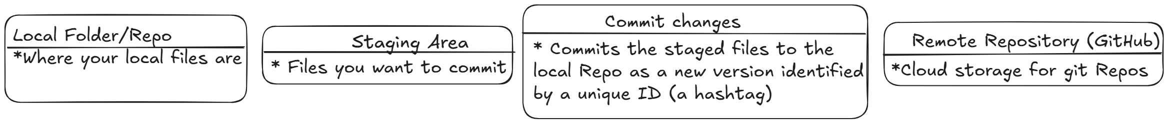
Local repository commands
git init : Initializes a local folder as a git repository
This means global to all repos on that user account on the computer. Only need this once.
git config --global user.name = “Your Name”
git config --global user.email = “Your email”
git add . : Adds all the files in the local repo to the staging area (. means all files)
git commit -m “Commit message” : Commits the files in the staging area as a new version

Pushing local repo to GitHub
git remote add origin URL : assigns a label called origin to the URL of the remote repo
git push –set-upstream origin master – Sets the location to push to. After this you can just use git push
git clone URL : Creates a local copy of an existing GitHub repository in a new local repo
It creates a new remote called origin so there is no need to set the upstream path
You can make changes to the local repo and push the committed changes to GitHub as usual
git pull : pulls the changes in the remote repository on GitHub to your local repo

Looking at some info in your repo
git config –-global -–lis : Shows your global info like name and email
git status : Shows which files are modified but not staged, what branch you are on, which files are staged (ready to commit) and other information at different times
git log : Shows the history of commits and some information about them
git diff : Shows the changes between the local repo files and the staged files


**The URL of the remote repo(on GitHub) for creating the remote up stream path or cloning a remote repo can be found by clicking the button in the GitHub repo.

